**AWS Application Migration Service**

* [Refer Here](https://docs.aws.amazon.com/mgn/latest/ug/what-is-application-migration-service.html) for the official documentation of application migration service  
  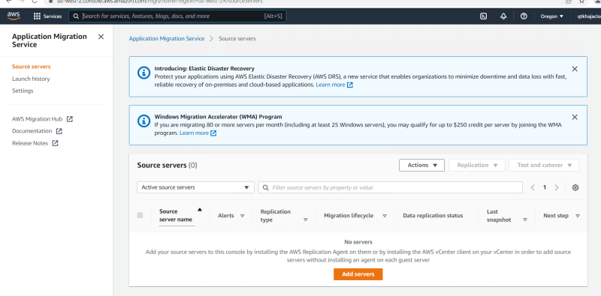  
  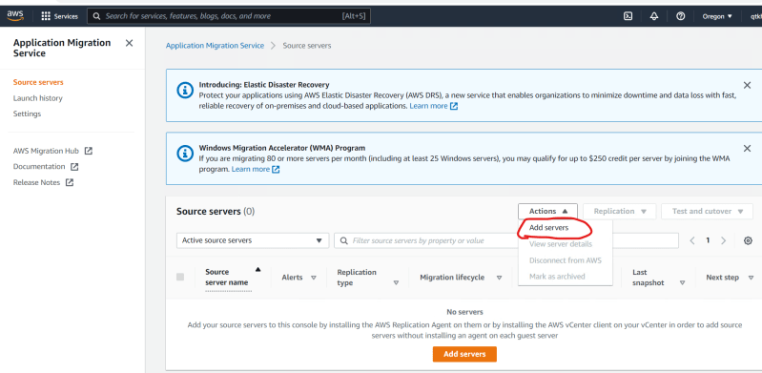
* Install the Replication Agent into your linux or Windows instance  
  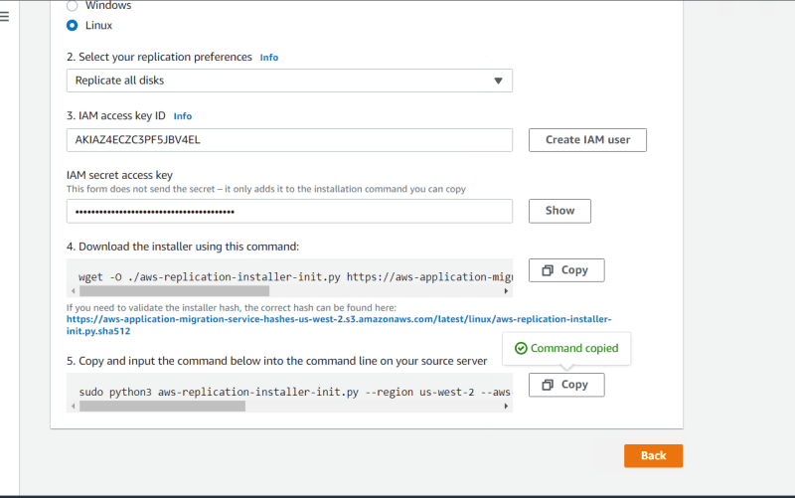
* Once the Source Servers are Setup we can start the migration
* Architecture  
  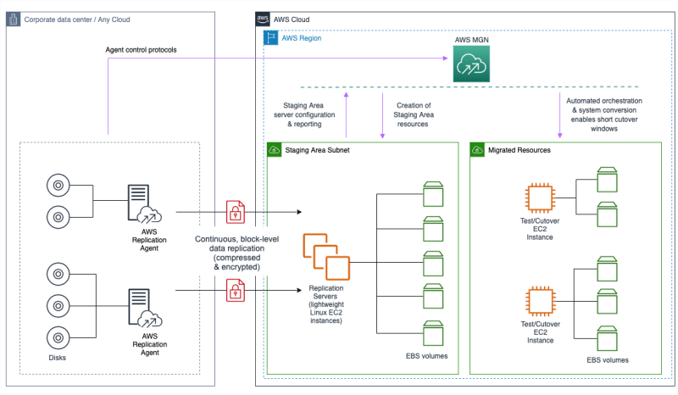
* For VMWare AWS Application Migration Service the agentless migration can be done [Refer Here](https://docs.aws.amazon.com/mgn/latest/ug/agentless-mgn.html) & the architecture is as follows  
  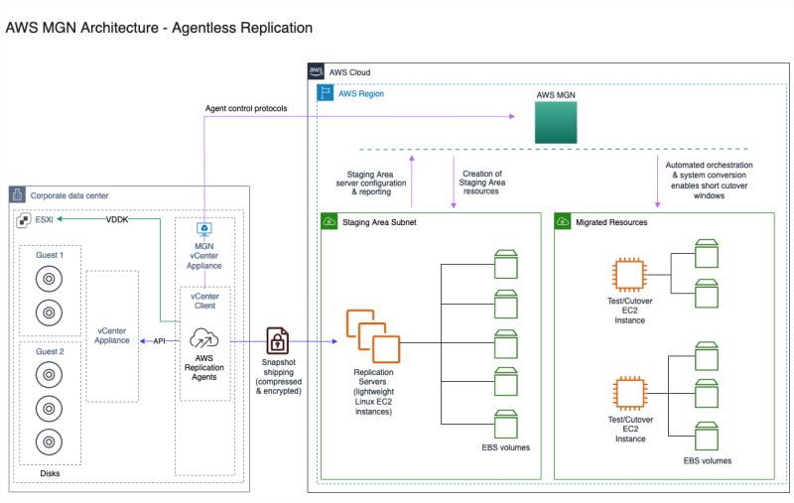

**Note:**

* [Refer Here](https://www.youtube.com/watch?v=GJN_ZftBkSY&list=PLuVH8Jaq3mLuqXuGs6aeqxhuvCYSzB1kT&index=3) for migrating VMS from VMWare to AWS using Server Migration Service.